ENDODONTICS

**Single sitting Root Canals: -**To reduce patient visits, the lengthy procedure of root canal is done in a single sitting. It is a painless and comfortable process usually done with the help of a machine.

**Multiple sitting Root Canals: -**It is the traditional and the best way of doing root canal treatment. The patient needs to visit twice or thrice for the procedure.

**Rotary Root Canal Treatment: -** This process is usually done with the help of a machine named endomotor. It is latest technology combined with the international quality medicaments to do the RCT. It can be single sitting or multiple sitting.

**Re-Rct: -**Re Root canal treatment is done when you develop infection in the previous RCT or done when the earlier RCT is faulty.

**Post and Core: -**When the tooth becomes weak or when the tooth structure is very less, the procedure of post and core is done to give an extra strength to the tooth.

**FAQ’s**

Question: Why is single sitting RCT better?

Answer: Single sitting RCT can be done in patients with acute infection and when no pus formation is present. It is painless and saves multiple trips and multiple jabs of anesthesia at the dental clinic.

Question: Why do we need Re-RCT?

Answer: Your dentist may recommend a Re-RCT when the older RCT was not done properly and infection has remained behind. Also if re-infection has taken place in an old RCT, this usually happens when crown is not placed after RCT.

Question: What exactly is a post?

Answer: Imagine a room with 4 walls and a ceiling, if 1 or more walls has collapsed; it’s not possible to hoist the ceiling over it. Similarly, if 1 or more walls of a tooth have collapsed due to cavities, after RCT, a post (made of metal or fiber) is place to reinforce the broken tooth wall and help with increasing surface area to place a crown or to make the tooth more viable for chewing.

Question: When is multiple sitting RCT suggested?

Answer: When the infection is chronic and the patient has been ignoring for a long time, there is pus, swelling, inflammation and severe pain, multiple sittings are needed to drain the pus and slowly restore the tooth health with medicaments placed inside the tooth canals and antibiotics.

Question: Whenever there is pain in tooth does it indicate that the RCT required?

Answer:

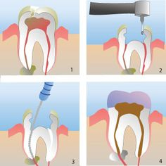

Image source Pinterest (For original type- root canal procedure illustration)

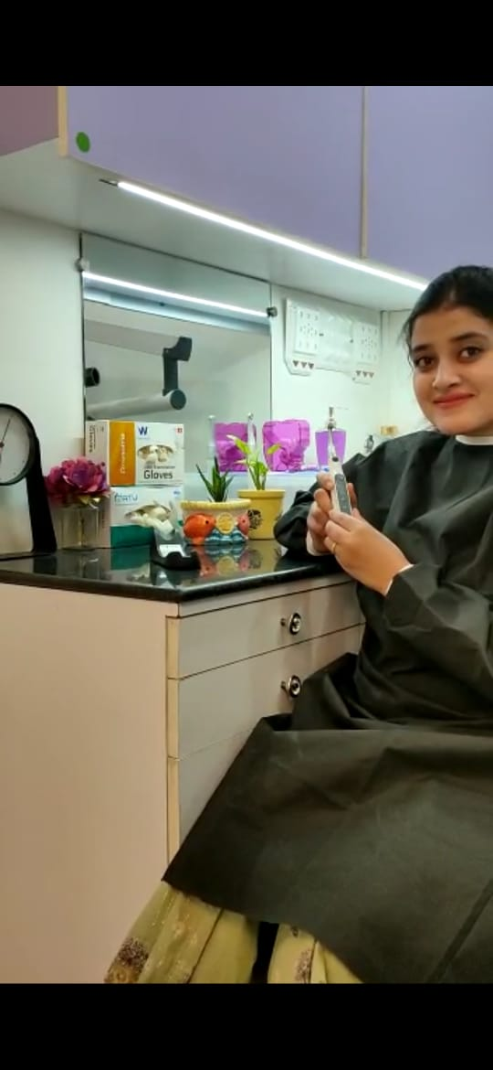

Dr Mahima displaying the Endomotor and Apex locator system, a state of the art system which allows us at Family Dental Dwarka to do Root Canal procedures with motorized filing instruments. This benefits out patients hugely by being pain free, quick and convenient and increases the accuracy much more compared to the old manual technique of doing RCT.

PROSTHODONTICS

**PFM Crowns: -** These are crowns with a metal framework inside and a porcelain (white) layer outside. They are usually indicated for posterior teeth.

**Zirconia Crowns**: - These are complete ceramic crowns which are aesthetic and biocompatible. They resemble natural teeth perfectly owing to our precise and reliable lab work at Family Dental Dwarka. These are usually indicated for anterior or front teeth. (Figure 1)

**E-Max Crowns: -**Ceramic crowns which are much more aesthetic and translucent which make them look like our natural tooth. (Figure 2)

**Complete Denture: -** If the patient does not have a single tooth in his mouth then this is an option. It’s a plate with a complete set of teeth which is custom made.

**Implant-supported Denture:-** In case the patient is missing all his teeth since a long time, the jaw bone on which the denture is placed tends to wear out or shrink, due to this it does not support the denture properly. To increase retention and stability of the denture, implants are placed at specific sites so that the underside of the denture can hold on to the implant heads and the denture gets the desired support that it is missing. (Figure 3)

**Removable Partial Denture: -**These are advised to patients who have few missing teeth. These are rigid (with clasps) & flexible which is made up of silicon.

**FAQ’s**

Question: Why do I need a crown?

Answer: After RCT, all the infected parts of the tooth are removed, due to which it’s strength decreases. To reinforce the strength of the tooth and restore its chewing surface in order to eat food properly, a crown is needed.

Question: Is crown procedure painful?

Answer: No. since the RCT has already been done, there is no sensation in the tooth. You will not feel the procedure at all.

Question: How many sittings does crown procedure take?

Answer: The crown procedure takes only 2 sittings.

Question: Which labs are used for making the crowns?

Answer: We work with only the best labs in Delhi and a nation-wide popular lab called Dentcare in Kerala. Till date no patient has been dissatisfied with the quality and precision of our lab work.

Question: Will there be any discomfort after getting crowns?

Answer: A strange sensation is felt after getting a crown for the next 1-2 days since it’s a new device in the mouth. This is in no way painful or uncomfortable.

Question: Which crown is better for my case (Metal/PFM or Zirconia)?

Answer: Althought both kinds of crowns work for all teeth, owing to simply their esthetic quality, PFM crowns are usually indicated for back teeth as they are slightly darker in colour. Zirconia or E-max crowns are generally indicated for front teeth as they resemble natural teeth more.

Question: How much does Zirconia or E-max crown cost?

Answer: At Family Dental Dwarka, we don’t believe in overcharging our patients for the sake of expensive dental treatment. Our prices are very affordable and we assure quality which is pocket friendly as well. The much popular Zirconia or E-max crowns which are rumoured to very expensive start from 8000 Rs in our practice.

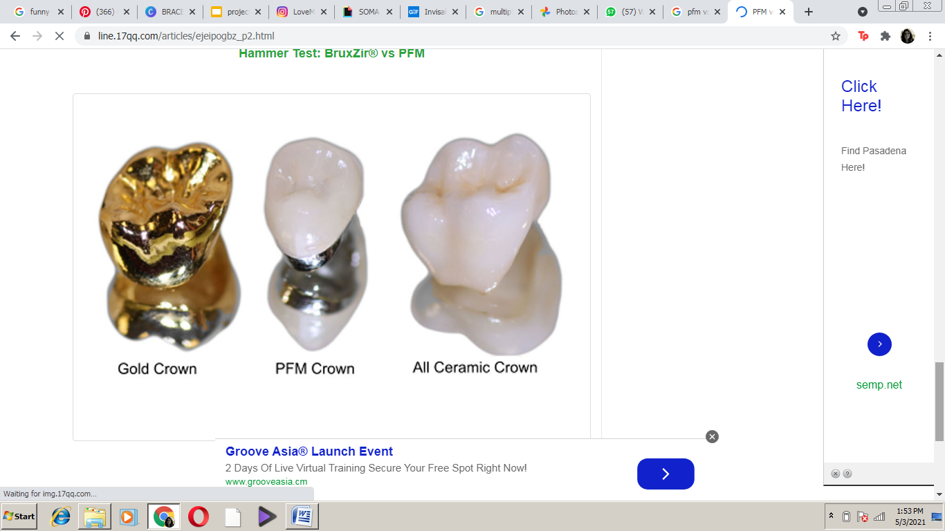**Figure 1**

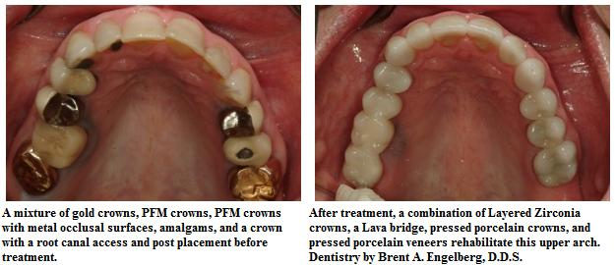

**Figure 2**

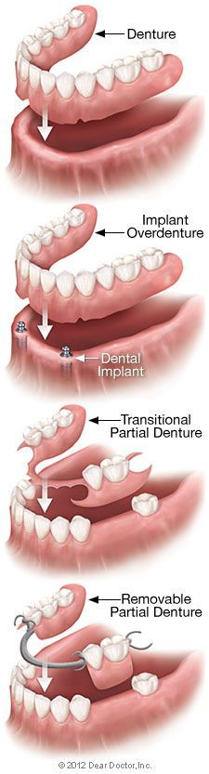

**Figure 3**

**PERIODONTICS**

**Scaling &Polishing: -** This is done to remove the soft and hard debris deposit on the teeth. This procedure restores your gums and bone health which is deteriorated by debris. Ideally, it should be done every 6 months.

**Root Planning: -**This procedure is done to remove the deep embedded debris from the gums and to remove the infected layer of roots of teeth to make them more hard and smooth. This is only done when indicated by the dentist.

**Curettage: -**It is a minor surgical procedure done to clean the deep embedded debris which is not accessible with root planning. This procedure restores the gum health significantly and is very effective for infected, inflamed, bleeding and swollen gums with chronic infection.

**Gum Depigmentation**: - Pink healthy gums are an integral part of a beautiful smile. Dark and pigmented gums ruin your smile. To correct this condition, gum depigmentation is done to remove dark spots from the gums. It’s a pain free procedure done by our on-call Periodontist (Gum Specialist) with laser which makes it extremely precise and comfortable. (Figure 1)

**Periodontal Flap Surgery**: This is a Surgical procedure to cure severe bone and gums diseases which can’t be cured by antibiotics, scaling and Root planning and even curettage.

**FAQ’s**

Question: Does scaling/cleaning remove top layer of the tooth?

Answer: No. Scaling is done using only a fast jet of water to remove the debris from top layer of teeth. When done properly, it does not damage the enamel in any way.

Question: Does scaling loosen our teeth?

Answer: No. Scaling only removes the top most debris layer using a fast jet of water. Sometimes when there are very heavy deposits between teeth, their removal gives a false feeling of teeth feeling loose. After following the correct precautions and dentist’s instructions, this feelng is overcome in 1-2 days.

Question: Will Flap surgery will be painful?

Answer: Flap surgery is a specialized procedure done by our on-call Periodontist. We take complete care to ensure that the patient feels little to no pain during this procedure.

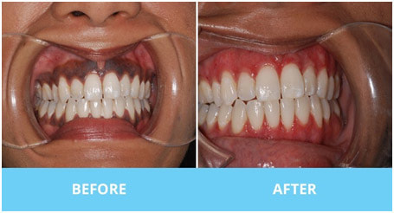

Figure 1

ORTHODONTICS (BRACES)

Braces are the most popular means of treating crowded, spaced or forwardly placed teeth since centuries. Once every decade technology takes a leap and unlike olden times, the newer braces are much more comfortable, faster and less visible. We at Family Dental Dwarka provide the most economical braces packages in Delhi NCR.

* TYPES OF BRACES
* DIFFERENCE BETWEEN TYPES OF BRACES
  + Traditional braces (Image 1) are the oldest form of braces and the most widely used variety.
  + They are of 2 types: Metal braces (slightly more visible, more sturdy), Ceramic braces (Slightly less visible, preferred by girls and older teens).
  + Traditional braces are ligated (attached) to the main u-shaped wire by means of an elastic called module. The modules are changed at every visit, but it has been observed in patients treated over many years that:
    - Extractions are necessary in most cases
    - Tightening is compulsory every month
    - Modules get discoloured by food stains (image 2)
    - Food collects more around modules
    - The tightening process done at every visit results in slight soreness for next 2-3 days
  + Self-Ligating or Automatic Braces (image 3) also come in a Metal and Ceramic variety.
  + Self-ligating braces do not need modules for tightening. They have a built-in clasp which tightens over the main wire itself, not needed external tightening. This gives the system and edge over the traditional braces:
    - Extractions can be avoided in most cases
    - Self activated, tightening not compulsory every month
    - Ideal for busy students, more comfortable with less visits
    - No modules, no discoloration
    - Smaller in size, less visible, less food build up
    - No tightening needed, no soreness after every visit
* WHAT IS THE BEST TIME TO GET BRACES
  + The ideal time to get braces is after all the milk teeth of the child have been replaced by permanent teeth, although this age can vary in children due to different eating habits.
  + This age coincides with puberty in children; any changes made to the teeth are readily accepted by the body.
  + Owing to newer advancements in the field of dentistry especially digital scanning procedures, there is no upper age limit of braces treatment. Adults of all age can undergo this treatment.
* WHAT ARE RETAINERS AND WHO NEEDS THEM
  + After the treatment is over, the teeth breathe freely after months and immediately try to go back to their original position. To remind them of their new position, they are restrained or held in place by a device called retainers which prevents them from going back to their original position.
  + Retainers can be removable (for children), invisible (for teens) or fixed at the back surface (for adults) (image 4).
  + They need to be worn for 6-12 months depending on the original condition of teeth.
* WHAT DO I EAT OR DRINK AFTER GETTING BRACES
  + We understand that in growing years, it’s difficult to put eating restrictions on children or teens, let’s face it, we love pizza too!
  + There are simple food restrictions with braces, which if followed can allow you to eat all your favourite foods with ease.
  + The rule is never to eat from the front teeth, always break or cut food into small pieces and eat from the back teeth, the chewing continues but the biting stops.
  + Avoid extremely hard or sticky things, especially raw apple or guava, popcorn, walnuts, five star, éclairs etc.
  + If you are innovative and careful you can eat almost anything. If craving pizza, avoid the crust and eat the middle with fork and knife. If craving ice cream, avoid the cone ones and choose the cup ones. If craving chocolate, avoid the fruit and nut ones; choose a plain one, slightly microwaved.

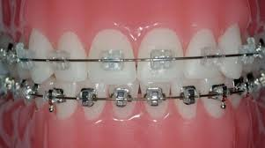 image 1

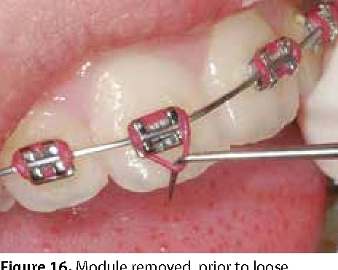 image 2

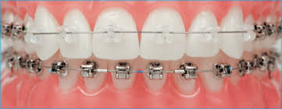 image 3

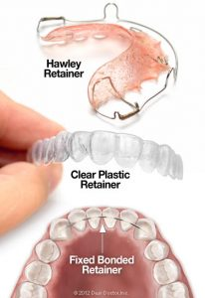 image 4

PEDODONTICS (CHILD DENTISTRY)

* Child dentistry in Family Dental Dwarka is handled by our seasoned Pedodontist or Child Specialist who has special training in handling the young ones of all ages with ultimate patience and care.
* The clinic has experience in dealing with children as young as 6 months and as old as 12 years. At our practice we believe that simply removing milk teeth thinking they will be replaced in the future is not the solution. Milk teeth are place holders for permanent teeth which erupt at their designated time. If this schedule is disturbed then teeth become crowded or forwardly placed and the child ends up getting braces.
* To avoid more serious treatment in the future, milk teeth should be preserved by simple means such as root canals and crowns for milk teeth by a specialist.
* PAINLESS ROOT CANAL FOR KIDS
  + When the milk tooth gets infected, the child presents with pain, swelling and difficulty in eating. If the permanent tooth is not due for more than 3 months, the milk tooth is retained by root canal.
  + This procedure at Family dental Dwarka is done by our Pedodontist. It is virtually painless, comfortable and is done at the pace most suited to the patient and parent mentalities.
  + We try our best not to use anesthesia so that the patient is more cooperative and trusting. In cases where anesthesia is needed, the finest needle used for insulin injections is used, so that the child barely feels the prick and is more cooperative with the treatment.
* CROWNS FOR CHILDREN
* After the root canal procedure, the tooth loses part of its structure and the child is unable to eat with it. A crown or cap is put to restore tooth substance and tooth strength.
* If the tooth is at the back and not very visible, a Stainless Steel crown is put. Depending on the child’s cooperation, this is usually a single sitting procedure and is absolutely pain free.
* If the tooth is in front, we can use semi permanent Composite Strip crowns or Polycarbonate crowns. These are tooth colored crowns and once the tooth becomes loose or the permanent tooth starts erupting, they can be easily removed painlessly.
* SPACE MAINTAINER
  + When a milk tooth is lost at an early age and the permanent tooth is not due for more than 3 months, a small device is put in its place taking support from neighboring teeth.
  + This prevents the collapse of the space left behind by the tooth, which will be needed for the permanent tooth to erupt in future.
  + In case this is not done, the remaining teeth drift into this space and occupy it, causing crowding, forward placement of teeth and random teeth positions, making the child a future candidate for braces.
* ANTI-CAVITY SEALANTS
  + Sealants are used for both children and adults to seal the depressions on the chewing surface of back teeth. This thin liquid flows into all the small depressions where food usually collects and causes cavities.
  + By sealing these areas, cavities can usually be avoided in the future in young children.
  + These are done at the age of 3, 5,7 and 9 years.
* FLUORIDE TREATMENT FOR CHILDREN
  + Fluoride is needed to support healthy enamel and provide an outer protective layer for the tooth.
  + In some cases where a child has white spots on teeth, has been consuming low fluoridated ground water or generally has weak enamel, external fluoride application is done.
  + It also helps in remineralization or strengthening of weakened areas of enamel.

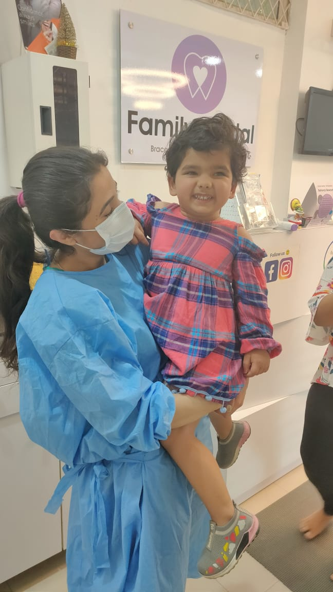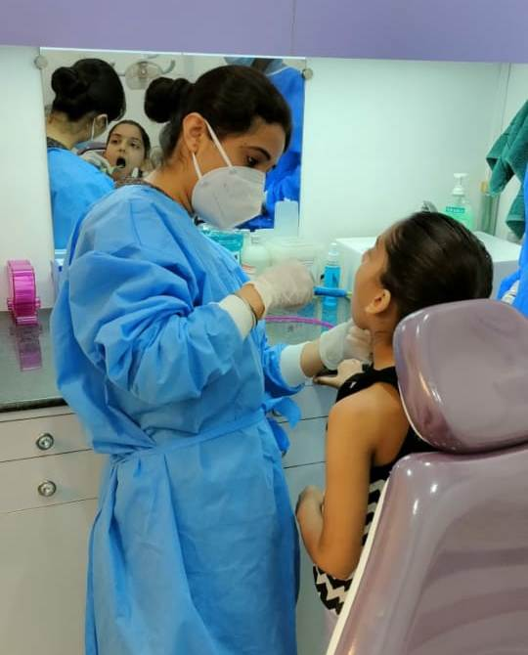

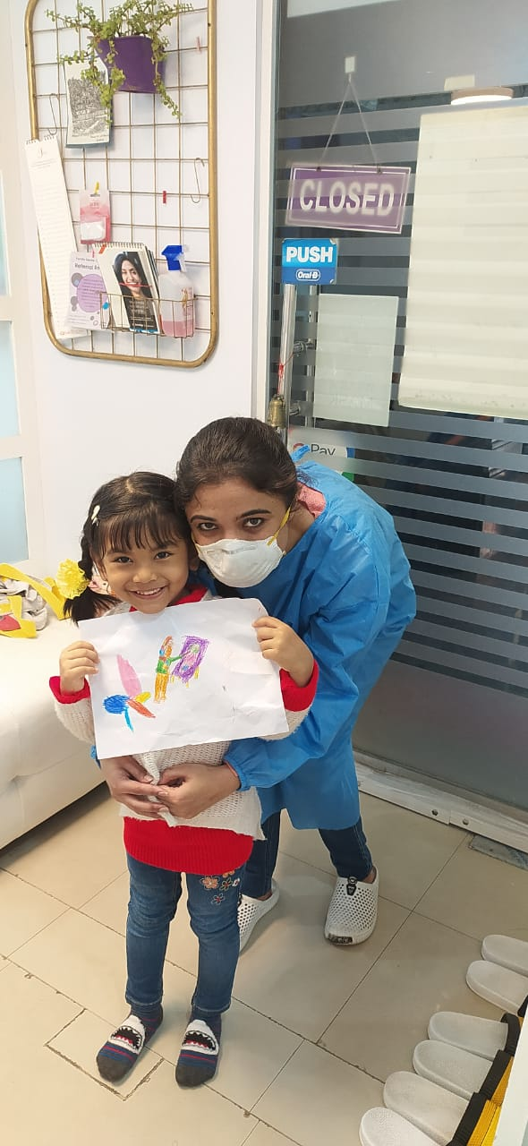

COSMETIC DENTISTRY

1. **ZOOM WHITENING**

* Zoom whitening technology uses specialized technology to whiten your teeth up to 8 shades lighter. It’s a relaxing procedure done within an hour at Dental Centre India where the patient can see miraculous changes in their tooth shades.
* Zoom whitening is extremely safe and some studies have even shown that it helps in strengthening the enamel.
* FAQs:
  + Q: How long does Zoom whitening last?

A: It lasts from 12-24 months but the success of treatment depends on certain eating habits and avoiding some food groups that can stain teeth.

* Q: Which foods need to be avoided after Zoom whitening?

A: One week after whitening, heavily colored foods and drinks like red wine, black coffee, dark colas, dark teas etc should be avoided. Smoking is also responsible for staining teeth after whitening is completed. Even after one week, these things should be avoided as much as possible to maintain the whiter teeth.

* Q: Who cannot get Zoom whitening done?

A: People with multiple crowns and veneers especially in the anterior region are not a candidate as the artificial teeth do not pick up the new shade.

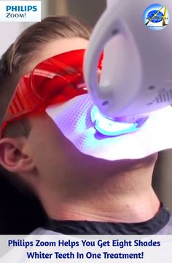

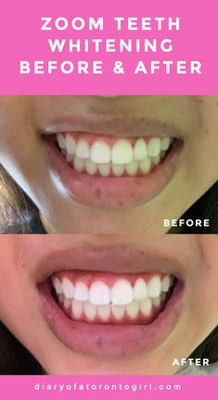

1. **SMILE MAKEOVER/VENEERS**

* Veneers are thin tooth colored shells that cover the front surface of a tooth to change its appearance in the desired manner.
* Veneers show instant smile correction and are the best means of smile makeover in a short span of time.
* Difference between crowns and veneers:
  + - * Veneers are applied only on front surface of tooth and need minimal grinding of tooth, crowns need grinding of entire tooth in all directions.
      * Usually Root canal is not necessary for veneer placement unlike in a crown.
      * It helps in conserving enamel.
* They can used in the following cases:
  + - * Chipped or broken tooth
      * Discolored tooth
      * Unusually shaped teeth
      * Uneven smile
      * Gaps between teeth
      * Very small teeth size

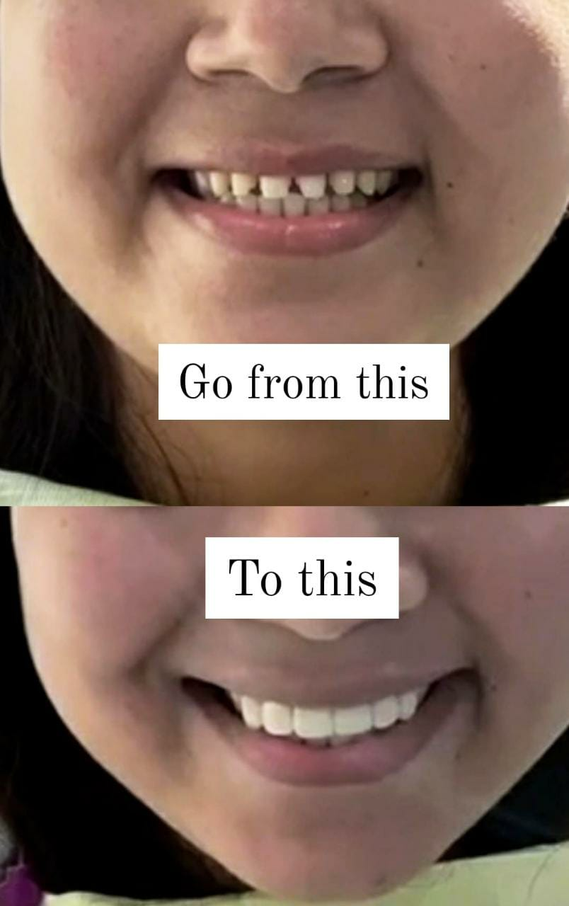

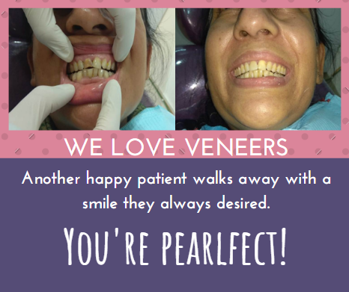

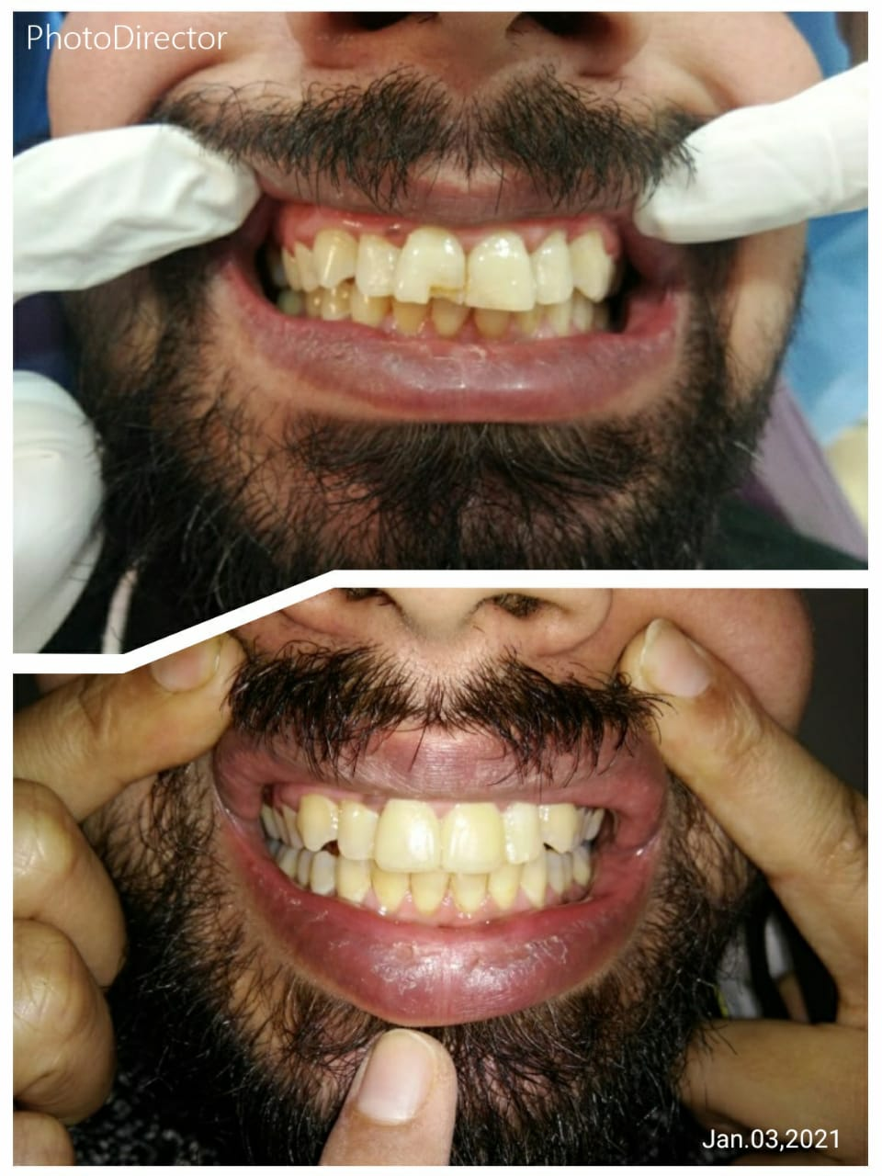

1. **TOOTH JEWELLERY**

* Tooth Jewellery is a small embellishment that is placed on the front surface of teeth
* It lets you sport a customized fashionable smile that is unique only to your taste.
* This procedure
  + Can be done in single visit
  + Painless
  + Enhances your smile



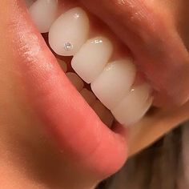

INVISALIGN

* Invisalign or any Clear aligners are an orthodontic device that is a transparent plastic form of braces.
* For patients needing fast correction of smile on the go, and unable to visit the Orthodontist regularly, unable to wear braces due to their professional or social concerns, this is the best and most reliable option.
* Dr Tushita Singh is a Certified Invisalign Specialist with more than 10 years of experience in Braces for adults and has finished hundreds of cases with perfection.
* She is also well trained in other aligner systems similar to Invisalign providing good results.
* ADVANTAGES OF ALIGNERS OVER BRACES:
  1. Completely invisible
  2. Can be easily inserted and removed by the patient
  3. Regular visits and tightening by doctor not needed
  4. No eating restrictions
  5. Treatment can be completed even while being in touch with doctor over phone
  6. Teeth issues like gaps between teeth, overlapping teeth, forwardly placed teeth can be easily corrected without extractions.
  7. Works for teens and adults both.
* WHAT IS THE PROCESS OF ALIGNER TREATMENT
  1. Meeting with the doctor for impressions, photos and scan of teeth
  2. Doctor works on back end and makes an animated video of before and after corrections of teeth, this is customizable based on patients requirement
  3. The final video is shared with patient for the viewing, this is done over mail hence patient presence is not necessary
  4. The final video is approved and aligner sets are manufactured
  5. If patient is available, they are given the sets and explained the procedure of wearing them
  6. If patient is not available, the aligners are shipped to them directly with instructions of how to wear them
  7. The doctor keeps a check on the treatment via WhatsApp or Skype.



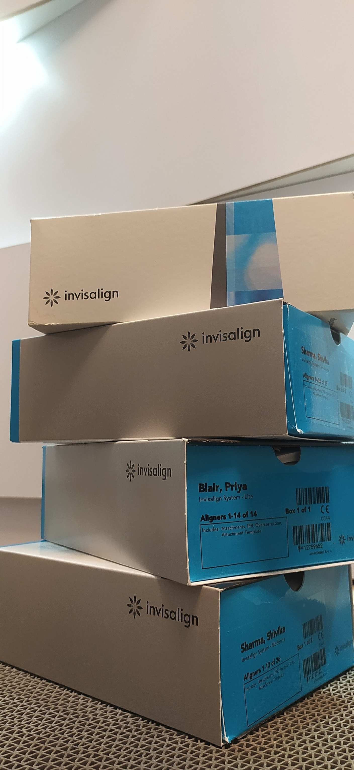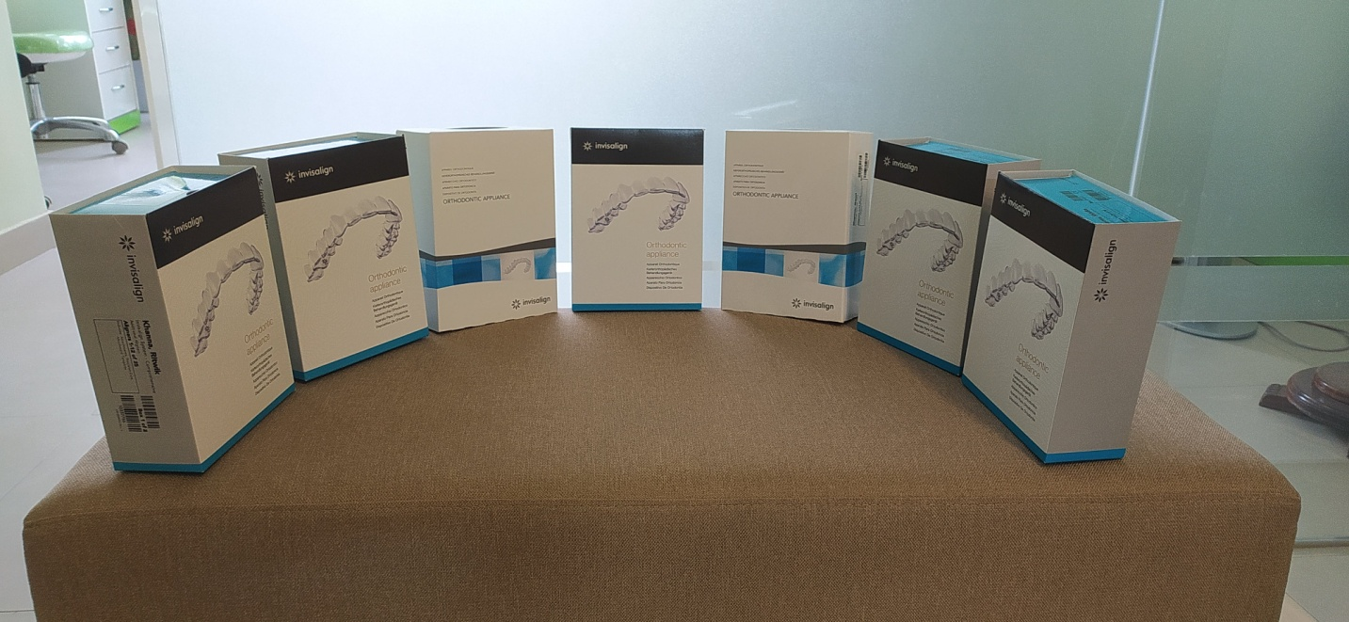

(I can mail you the originals of all these images, we want to include them in gallery too)

